## Lab 4a - Forking a repository

*Note: For the sake of these tutorials, we are assuming you are using a terminal capable of running Bash commands. For Windows users, the recommended terminal program for this is Git Bash, which you can download [here](https://gitforwindows.org/).*

This practice gets you to fork a remote repository.

1. Make sure you're logged into your GitHub account
2. Go to any public repository available. [This one](https://github.com/tvaidotas/FlaskAppBasic) for example:  
   https://github.com/qa-apprenticeships/FlaskAppBasic
3. Click on **Fork** in the top right of the page for your chosen repository. This will create a copy of the repository under your account  
     
   Fork >
4. You will be redirected to your account's version of the repository
5. Click on the green **Clone or download** button, and copy the URL  
     
   
6. Open a Bash terminal in the location you want to clone your project
7. Run the command git clone [URL], but replace [URL] with the repository URL you copied in the previous step
8. Change directory to the project you just cloned
9. Run the following command, to confirm that you have cloned the correct repository:

$ git remote -v

You should get a similar output for fetch and push, but the URL will be pointing to your repository.  
  
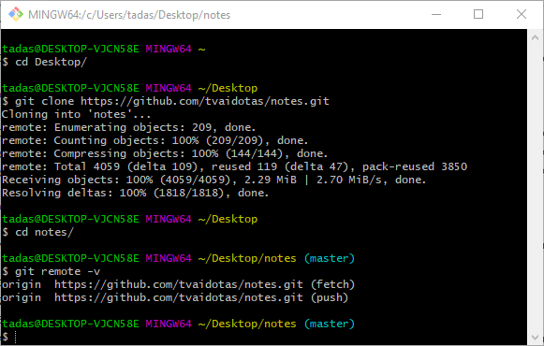

## 

## Lab 4b - Updating forked repository from original

Now you will set up your local project to receive updates from the original repository. This is required, so that when the owner of the original repository adds new functionality, bug fixes etc., you will be able to get these changes as well.

1. Open your Bash terminal, in the root directory of your project. You should be able to see that you're on the master branch. Next, you want to execute git remote -v to make sure that the upstream to the original repository is not set up yet.  
   You should see a similar output to this.  
     
   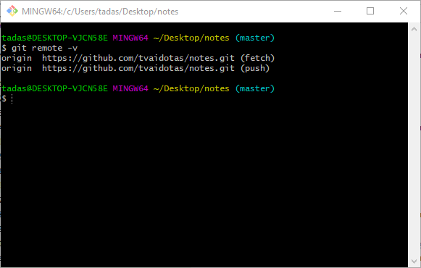
2. In your browser, go to the original git repository and copy the repository URL. You can do this by clicking on the green **Clone or download** button and copying the URL  
     
   
3. Execute the following command in your Bash terminal, but replace the [URL] with the one you just copied:  
    git remote add upstream [URL]
4. Next, you want to check that this has worked, which you can do by executing the git remote -v command.  
   The output should look similar to this:  
     
   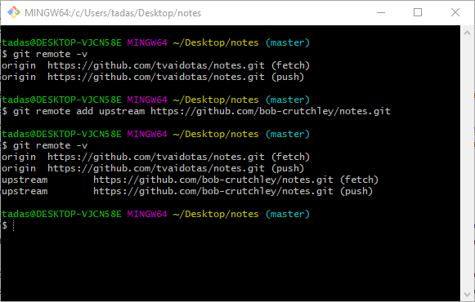
5. Now you will pull the changes from the original repository into yours, which you can do by executing the git fetch upstream command in your Bash terminal. The output will depend on whether there are new changes or not:  
     
   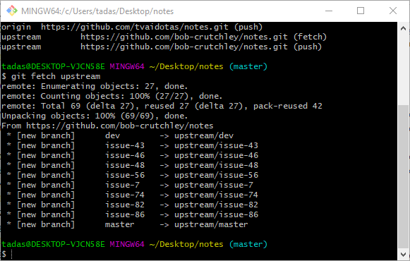
6. You will want to update the master branch, so we will merge the *upstream/master* into the *local origin/master*. You can do this  
   by executing the git merge upstream/master command. Keep in mind that there may be merge conflicts that you will need to resolve. If you have resolved the merge conflicts, or if there were none, you should *push* to update your *origin/master* branch.  
     
   